Inspection Data Report
Customer: | Cargill Food Solutions | Subject: | Inspection of the FRP Fructose Vessel ‘A’
Customer Address: | customer address | From: | Jean-Guy Gilbert  MAS Inspection Manager
Customer Contact: | customer contact | Company: | Maverick Applied Science, Inc.
Inspection Site: | Inspection site | Maverick Contact Info: | Cell Phone #: (205) 644-2251  Email: jggilbert@mas-mss.com
Customer PO No.: | customer po num | Maverick Job: | 20243401
Customer CCs: | customer ccs | Maverick CCs: | D. Mikulec; MAS Technical Director
Inspection Date(s): | Inspection date | Report Date: | report date
Introduction
The following report discusses observations from the on-site Inspection of the FRP Fructose Vessel ‘A’ at the Cargill Food Solutions facility in Dayton, OH. This report documents the current condition of this FRP vessel after being in service. The Owner has stated that they would like to put this vessel into a new service application, storing 7% HCl at Ambient Temp for a period of 2-3 months until a new HCl tank is fabricated and installed.
Entrance Meeting
Jean-Guy Gilbert of Maverick Applied Science, Inc. (MAS) met with Jair Carrasquero of Cargill Food Solutions upon arriving on site. The goals of the inspection visit were discussed, as well as procedural items such as access to the items and any safety concerns.
Inspection Documents Used During this Surveillance Visit:
- The following drawings were provided and used during the inspection:
  - Equipment Drawing: 6808 REV. 1, 04/21/1976 from Justin Enterprises
- The following specifications were used during the inspection:
  - ASTM D2563, “Standard Practice for Classifying Visual Defects in Glass Reinforced Plastic Laminate Parts”
  - ASTM D2583, “Test Method for Indentation Hardness of Plastics by Means of Barcol Impressor”

Inspection Observations:
- Figure 1 shows
- Figure 2 shows
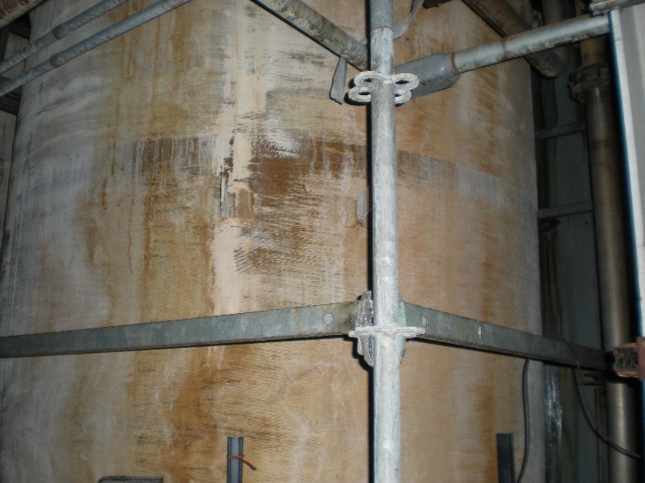  Figure 1: XXX | 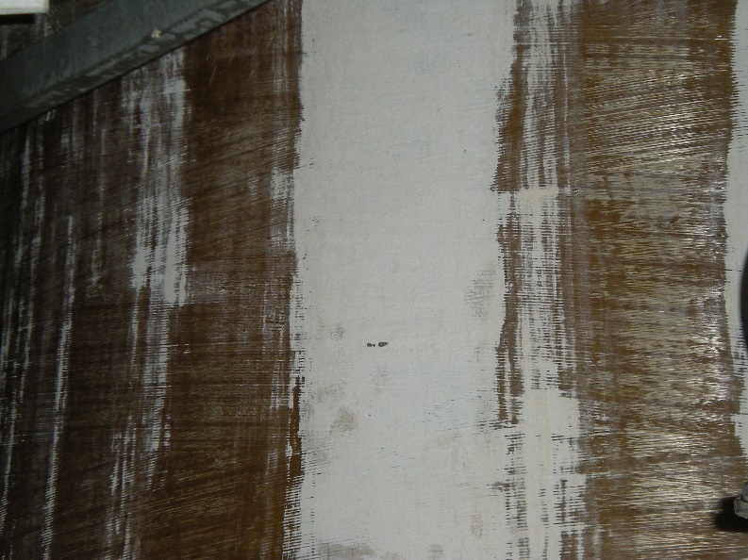  Figure 2: XXX
- Figure 3 shows
- Figure 4 shows
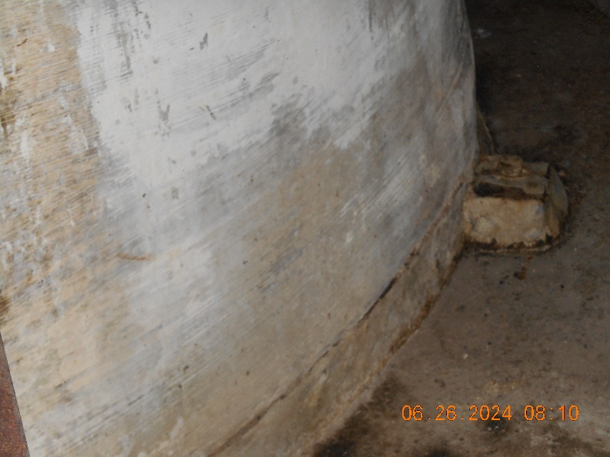  Figure 3: XXX | 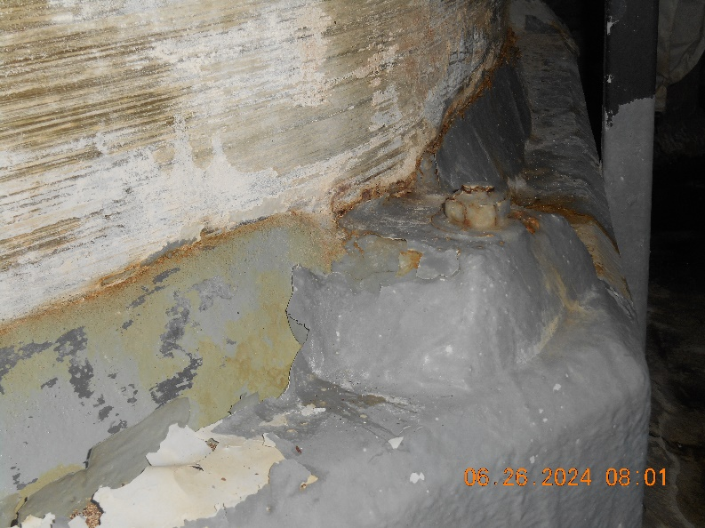  Figure 4: XXX

- Figure 5 shows
- Figure 6 shows
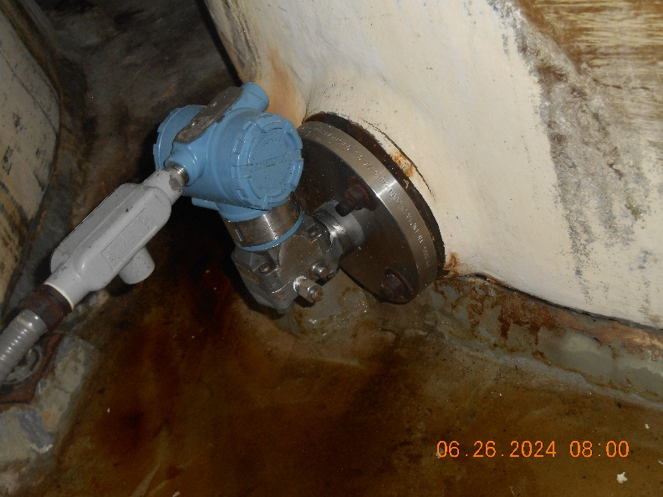  Figure 5: XXX | 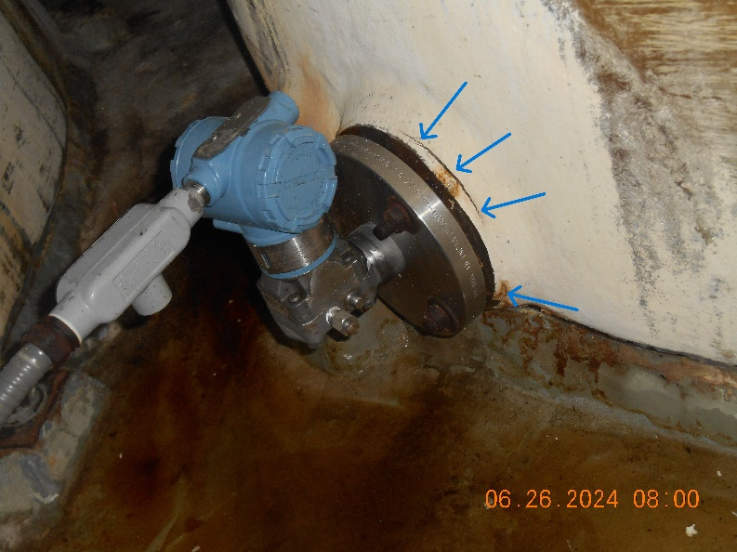  Figure 6: XXX
- Figure 7 shows
- Figure 8 shows
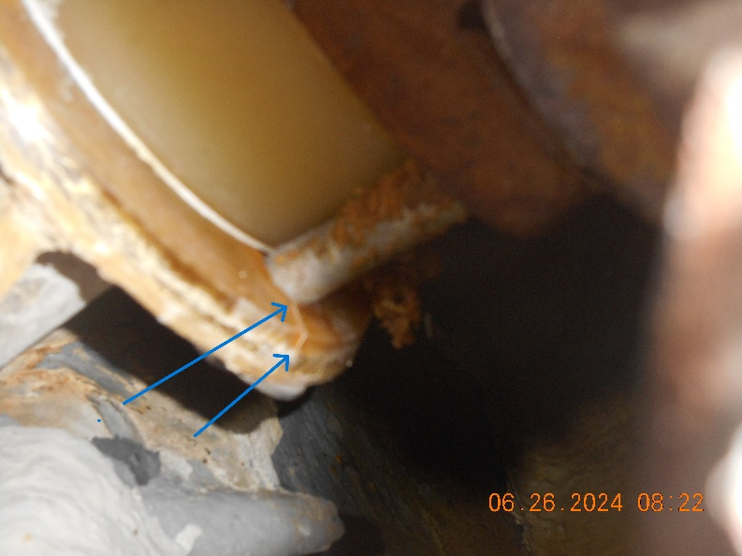  Figure 7: XXX | 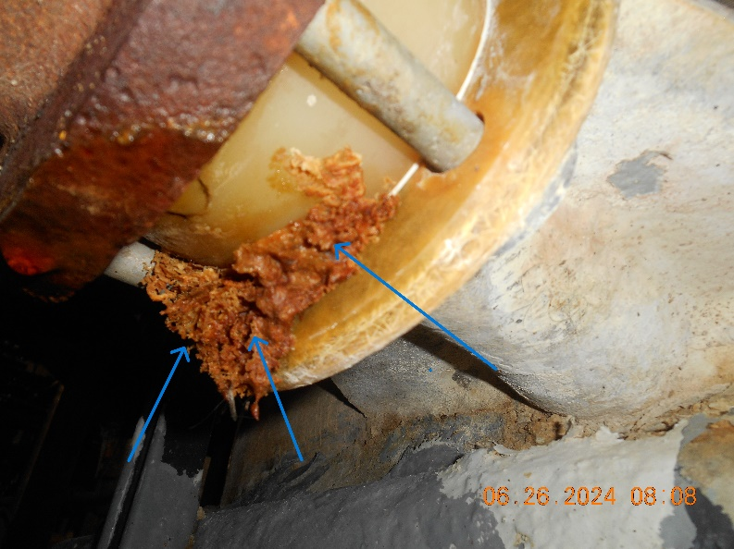  Figure 8: XXX

- Figure 9 shows
- Figure 10 shows
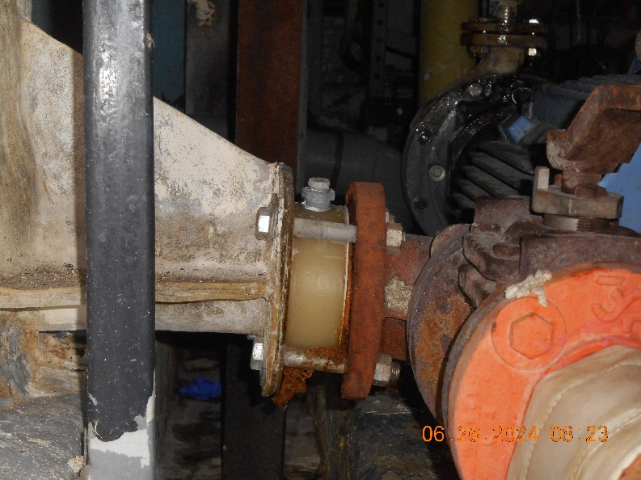  Figure 9: XXX | 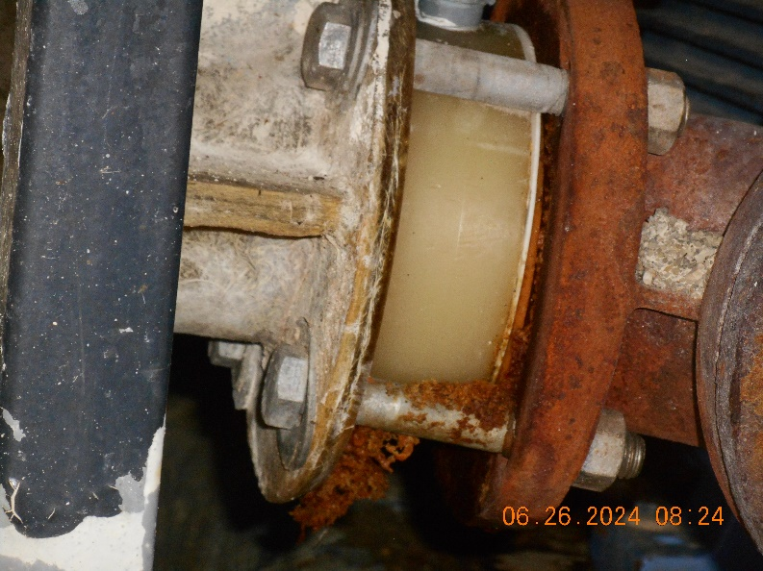  Figure 10: XXX
- Figure 11 shows
- Figure 12 shows
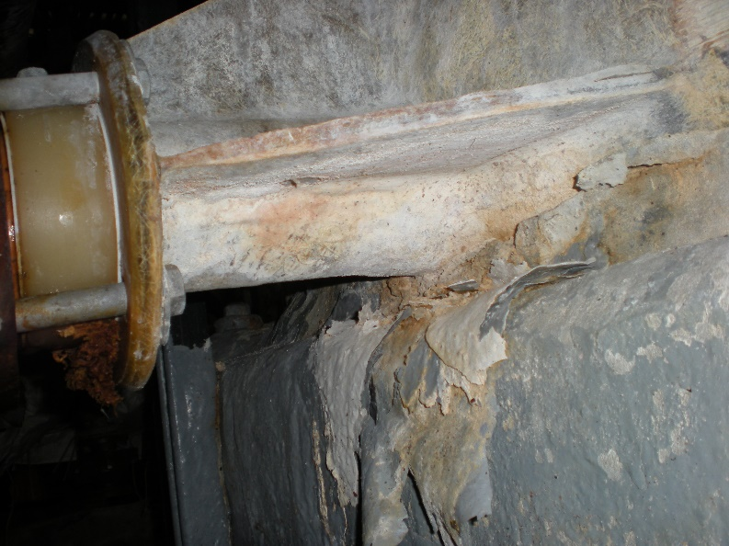  Figure 11: XXX | 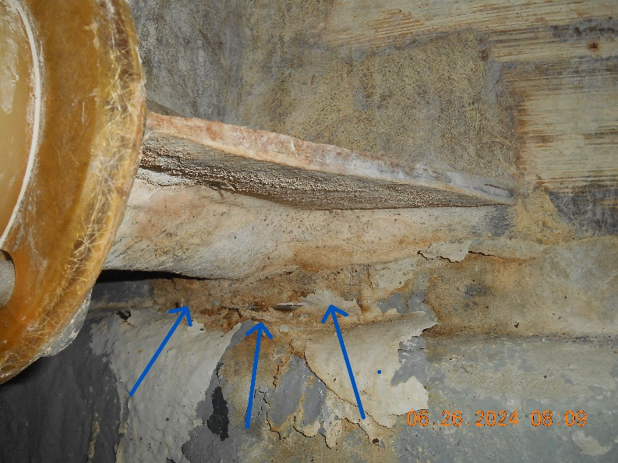  Figure 12: XXX

- Figure 13 shows
- Figure 14 shows
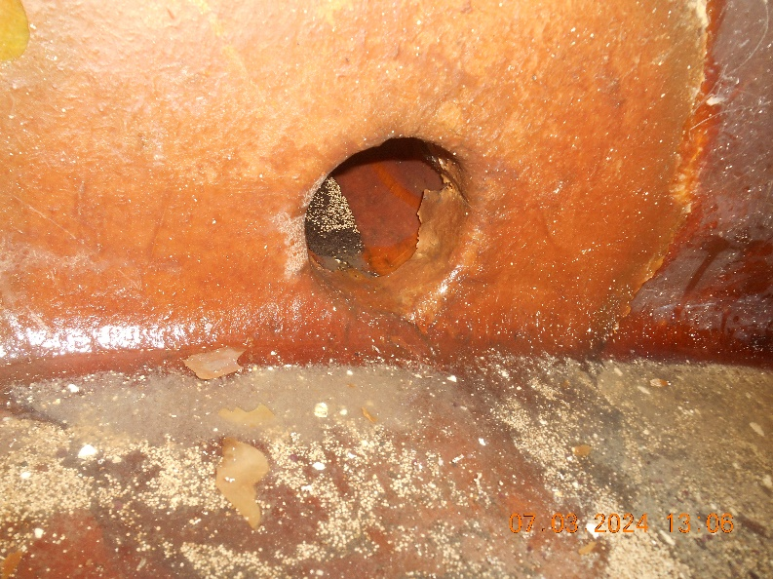  Figure 13: XXX | 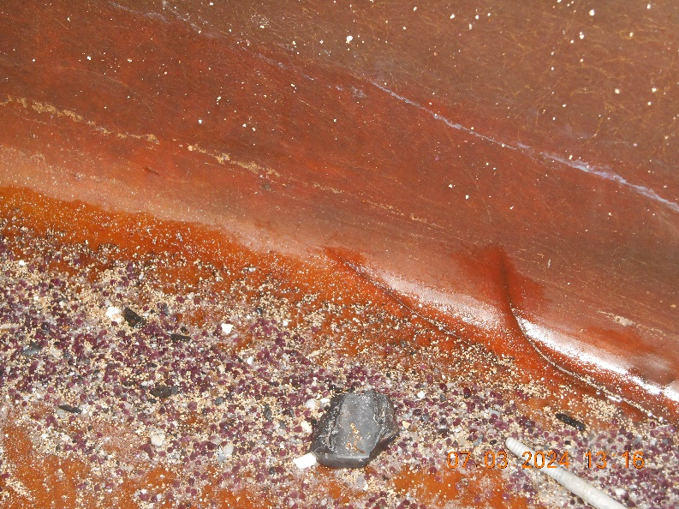  Figure 14: XXX
- Figure 15 shows
- Figure 16 shows
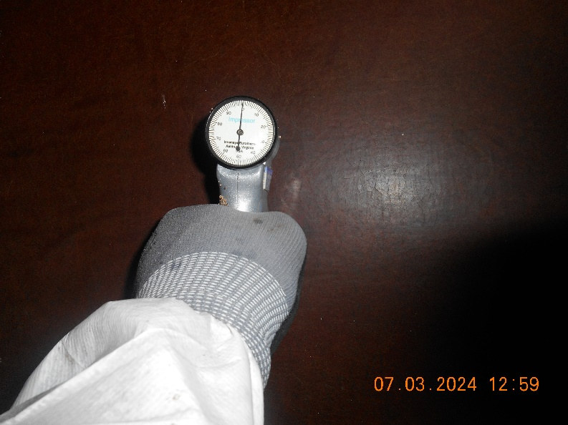  Figure 15: XXX | 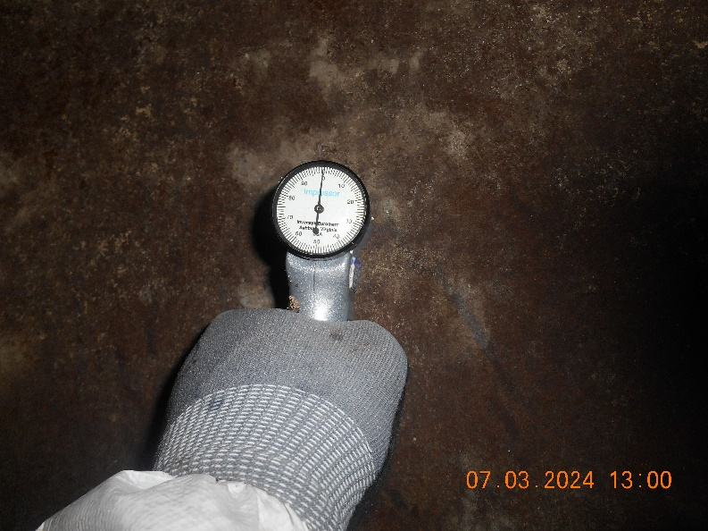  Figure 16: XXX

- Figure 17 shows
- Figure 18 shows
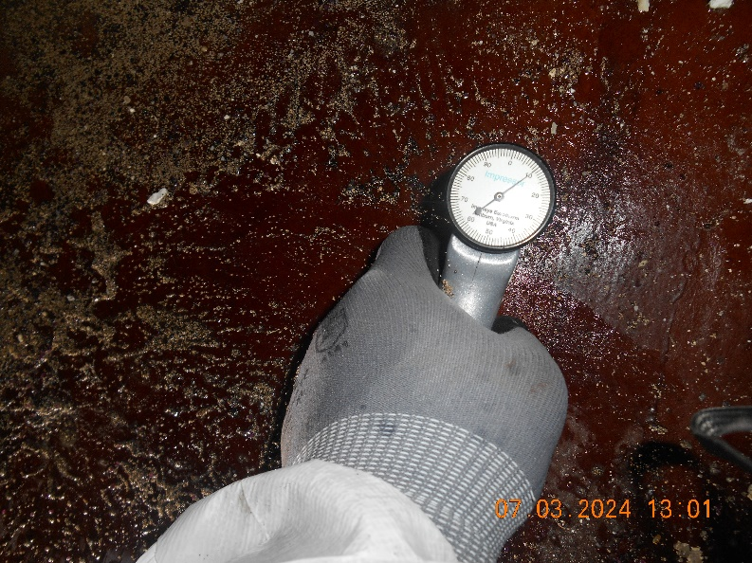  Figure 17: XXX | 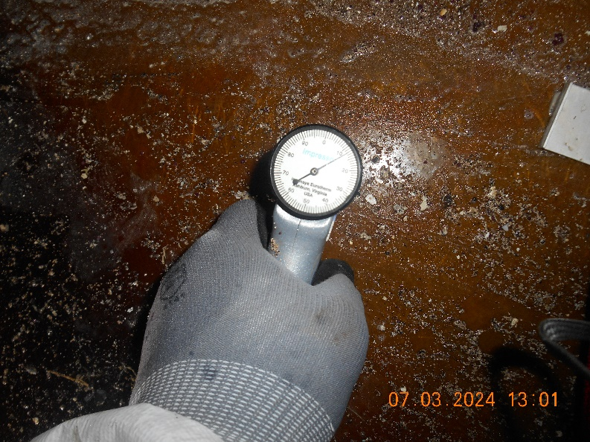  Figure 18: XXX
- Figure 19 shows
- Figure 20 shows
  Figure 19: XXX |   Figure 20: XXX

Inspection Conclusions and Recommendations:
- Considering the age of the vessel, as well as the results of the visual inspection and Barcol Hardness testing, this vessel should be seen to be at the end of its useful service life.
  - Barcol Hardness readings on the shell were 0, indicating that it is fully permeated and chemically attacked. Further, without prior inspection data, it is impossible to know when the readings reached 0.
  - Observed cracking and crazing also allows fluid to bypass the inner veil layer, which can lead to advanced permeation.
  - Internal overlay delaminations and cracking in the bottom knuckle are also sources of permeation and avenues for fluid to reach the structural wall or outside of the vessel, not to mention stress concerns in the bottom knuckle due to cracking.
- For these reasons, we recommend replacement of this vessel within 6 to 9 months. However, due to the lack of inspection data during its runtime and uncertainty of placing this vessel into a new service, we cannot offer any sort of guarantee for its operation if it is placed back in service.
- For extended reliable operation, internally relining the vessel with at least a full 100 mil corrosion barrier is recommended, potentially even with some structural reinforcements due to uncertainty regarding how long the corrosion barrier has been compromised. Due to the condition of the vessel, a detailed procedure is necessary for relining to ensure a quality bond to the existing substrate.
  - If the vessel is to be rehabilitated, a new flange at Nozzle G is necessary due to observed fractures, and the connected piping needs to be confirmed plumb so that the nozzle is not overloaded.
  - Further, Nozzle H would need to be repaired.
  - Since the vessel is indoors, the deterioration of the external gelcoat is not of such a critical nature. Future external painting of the vessel could be considered for general cosmetic appearances.
- If this vessel is rehabilitated, it is recommended to add a new 24” manway in the lower shell for an easier and safer way of accessing the vessel.
  - It is also recommended for hazmat marking to be updated.
  - If the vessel is to be replaced, the new vessel is recommended to have a manway included in the lower shell.
Respectfully Submitted,
Jean-Guy Gilbert
MAS Inspection Manager
Phone #: 205-644-2251
jggilbert@mas-mss.com

